INTEGRATIVE COURSE IN PSYCHOLOGY (ICOPSYCH)

ANALYSIS ON THE RESULT OF PRE-TEST EXAMINATION IN INDUSTRIAL PSYCHOLOGY
APRIL 12, 2025

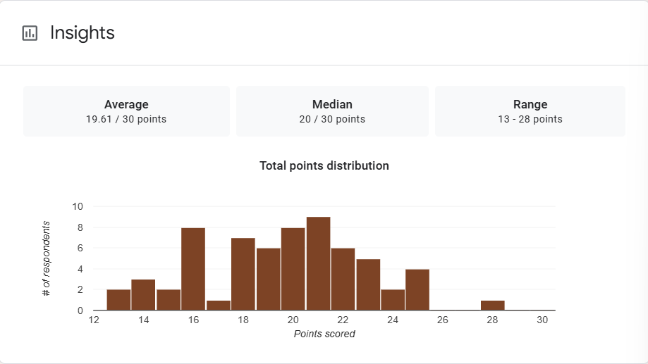

1. Mean Score: The mean score of 19.61 suggests that, on average, participants performed moderately well; scoring roughly 65% of the total possible points.

2. Median Score: The median score of 20 indicates that half of the participants scored above 20 and half below, reinforcing the idea of a fairly balanced distribution around this central point.

3. Range: The range (from 13 to 28) shows that there was a moderate spread in the scores, with a 15-point gap between the lowest and highest scores. This suggests variation in performance, but no one got a perfect score or failed completely.

Interpretation Summary:

-Since the mean (19.61) and median (20) are very close, the distribution is likely symmetrical or only slightly skewed, meaning there are no extreme outliers significantly pulling the average.

-The group generally shows a solid understanding of the material, with room for improvement at both ends, especially for those near the lower end of the range (13).

RATIONALIZATION:

DIFFICULT QUESTIONS:

